## General

1. ISB, Gilgit & Kashmir should be available as state in system
2. Searching should be more advance
3. Inquiry to entry jump should be available
4. Pending changes to form should be notified (like excel and other apps unsaved data)
5. Toggled Menu should remain open or closed after navigation
6. Parent to child tab should retain parent value
7. UI Arrangements should be revised (Discussion Required) (Data entry perspective)

## SL Accounts

1. Excel Upload not working need to check
2. Selected SL Account for child details should be visible (as top panel for other) selected info should appear on child tabs ( details and address tab)
3. AOP Entity Type to be added

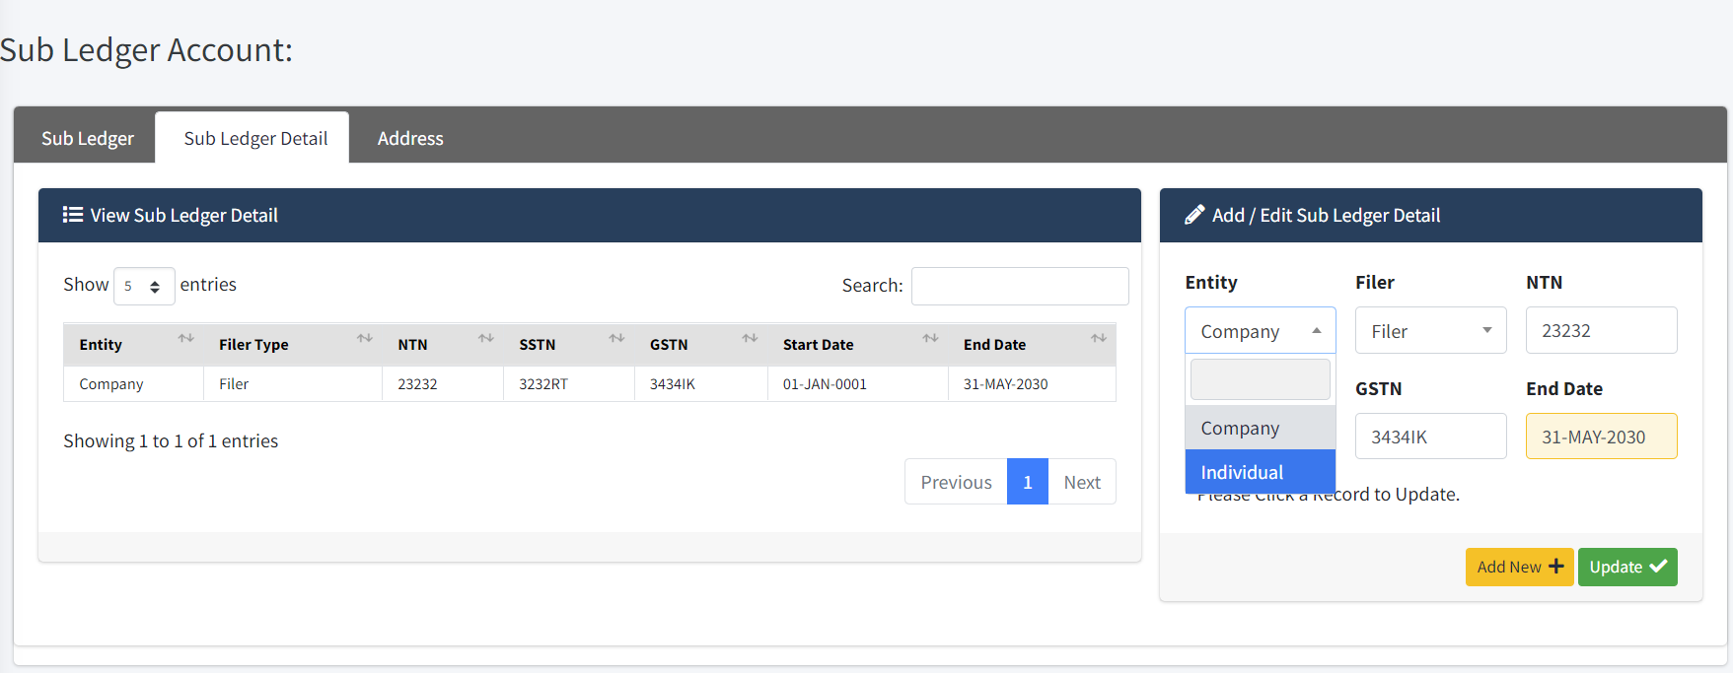

1. End Date for detail should not be mandatory ok will be done

## Advise Entry

1. COA Code should be shown in detail table. Add COA Code in the left grid.
2. Multiple entries for same COA should be allows (Can have different narration or cost center or any other detail) need to check( advice detail will contain income / expense / revenue and Sub ledger tab will contain Receivable / payable COA)
3. Searching of COA should be enhanced for accuracy. Edit row is showing select2, while in add new record, its showing simple select. Replace it to select2 also. But increase view size same like select.
4. Currency should be auto selected to PKR. Currency list must be filtered from branch currency mapping, if single then it must be selected by Default.
5. Document Upload option required multiple file Attachment option will be provided on Voucher header and advice header.

## Advise Inquiry

1. Sort by descending first will be done
2. Search parameters required search parameters already available on each column. LOV based parameters can be provided as requested page wise.
3. Advise was approved with fiscal year error ,will be checked. In case of any error, advice should not get posted.
4. Voucher for backdated advises not generated Period must be open for it

## Voucher Entry

1. Approved vouchers should be disabled for edit will be done
2. Vendor Should be selected for SL type of JV and then debit entry should be created accordingly.
3. PV knockoff screen should be available same as PR will be done
4. Bank account should be mandatory for bank COA item will be done
5. Tax demo required . setup demo done. Taxes should be uploaded.

## Report

1. COA Code should be visible in parameters will be done
2. SL Report Not showing approved vouchers will be done