Addition GF2021/P/00010-1-1 09June2022 - CATEGORY BASED
Addition GF2022/P/00002-1-0 17June2022 - Salary Multiple – Facultative

1-On click on alteration direct main document tab open. (Without any option Additions, Deletions Etc)
2-All Tab are Editable i.e (Document Tab, Benefits, Charge, Wakala etc)
3-Insured Persons>Download Active Items >Need Format Changes
4-Insured Persons> Effective Date is Locked i.e policy Commencement Date
5-Commencement & Additions Employees are showing in particular endorsement. (Current Active Employees List not showing).
6-Addition Charging on Annually.
7-Addition through Excel Upload> All Employees upload on different Effective Date But system upload with same Effective Date i.e policy Commencement Date
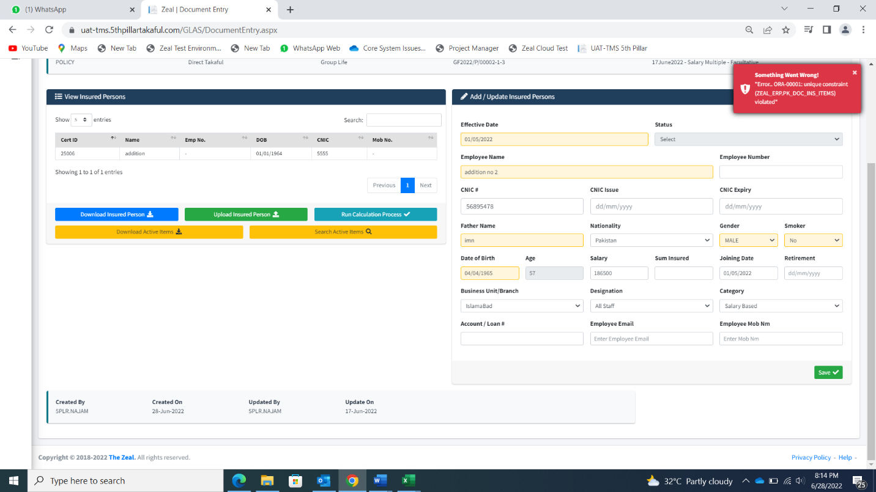
8-Insured Person> Member Addition from Form? On Second addition showing error (Error ORA-0001 unique constraint (Zeal_ERP.PK_DOC_INS_ITEMS) violated.

9-Deletion option is not available

